Experiment 5: Crypt Problem

Aim:
To solve the cryptarithmetic puzzle SEND + MORE = MONEY using Python by assigning digits (0–9) to letters such that the arithmetic equation holds true, ensuring each letter maps to a unique digit and leading digits are non-zero.

Algorithm:
Step 1: Identify Letters
Extract all unique letters from the equation: S, E, N, D, M, O, R, Y

Step 2: Define Constraints
- Each letter must map to a unique digit (0–9).
- Leading letters S and M cannot be zero.
- The equation must satisfy:
𝑆𝐸𝑁𝐷 + 𝑀𝑂𝑅𝐸 = 𝑀𝑂𝑁𝐸𝑌

Step 3: Generate Permutations
Generate all possible permutations of digits for the 8 letters.

Step 4: Apply Constraints
For each permutation:
- Check leading digit constraints
- Convert SEND, MORE, MONEY into numbers
- Check if SEND + MORE = MONEY

Step 5: Print Solution
If a valid mapping is found, display:
- Letter → Digit mapping
- Numerical values of SEND, MORE, MONEY

Flowchart:

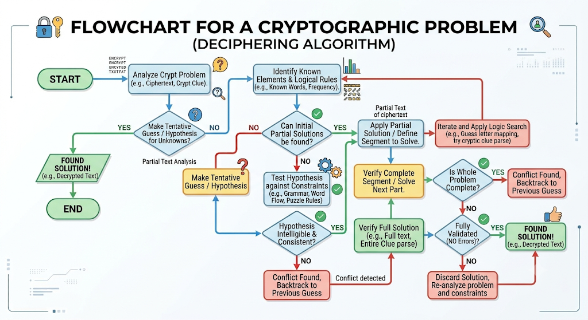

Source Code:

# Cryptarithmetic Puzzle: SEND + MORE = MONEY
# We solve by assigning digits to letters using permutations.

import itertools

def solve_crypt():
letters = ('S','E','N','D','M','O','R','Y')
digits = range(10)

# S and M cannot be zero (leading digits)
for perm in itertools.permutations(digits, len(letters)): mapping = dict(zip(letters, perm))

if mapping['S'] == 0 or mapping['M'] == 0: continue

SEND = (mapping['S']*1000 + mapping['E']*100 + mapping['N']*10 + mapping['D'])

MORE = (mapping['M']*1000 + mapping['O']*100 + mapping['R']*10 + mapping['E'])

MONEY = (mapping['M']*10000 + mapping['O']*1000 + mapping['N']*100 + mapping['E']*10 + mapping['Y'])

if SEND + MORE == MONEY:
print("Solution Found:") print("Mapping:", mapping) print(f"SEND = {SEND}") print(f"MORE = {MORE}") print(f"MONEY = {MONEY}")
return

print("No solution found.")

# Run the solver solve_crypt()

Output:

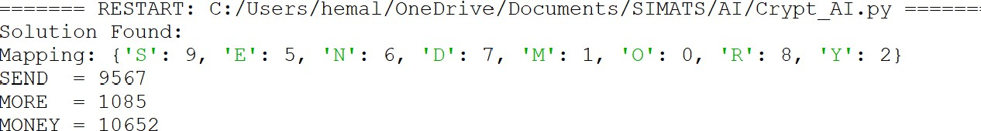

Result:
The cryptarithmetic puzzle SEND + MORE = MONEY was solved by assigning unique digits to each letter such that the arithmetic equation becomes numerically correct.
After applying all constraints and checking valid digit permutations, the correct digit mapping was found as:
- S = 9
- E = 5
- N = 6
- D = 7
- M = 1
- O = 0
- R = 8
- Y = 2
Using this mapping, the words convert into numbers as follows:
- SEND = 9567
- MORE = 1085
- MONEY = 10652
When adding SEND and MORE:
9567 + 1085 = 10652
This matches the value of MONEY exactly. Therefore, the solution is valid, satisfies all constraints, and correctly solves the cryptarithmetic equation.

